Chronology of Instrument Designs and Ideas

Sep-2016:

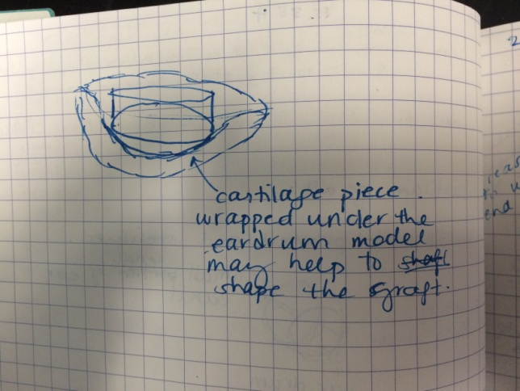

Problem: too much time to shape the cartilage graft in the appropriate shape. Solution: Cartilage 3D stencil to help shape the ear drum graft. A variant of this was tried before, and it took too long to print (too much time used) and the end result wasn’t perfect. Dr. James printed a 2D outline of the ear drum in that case.

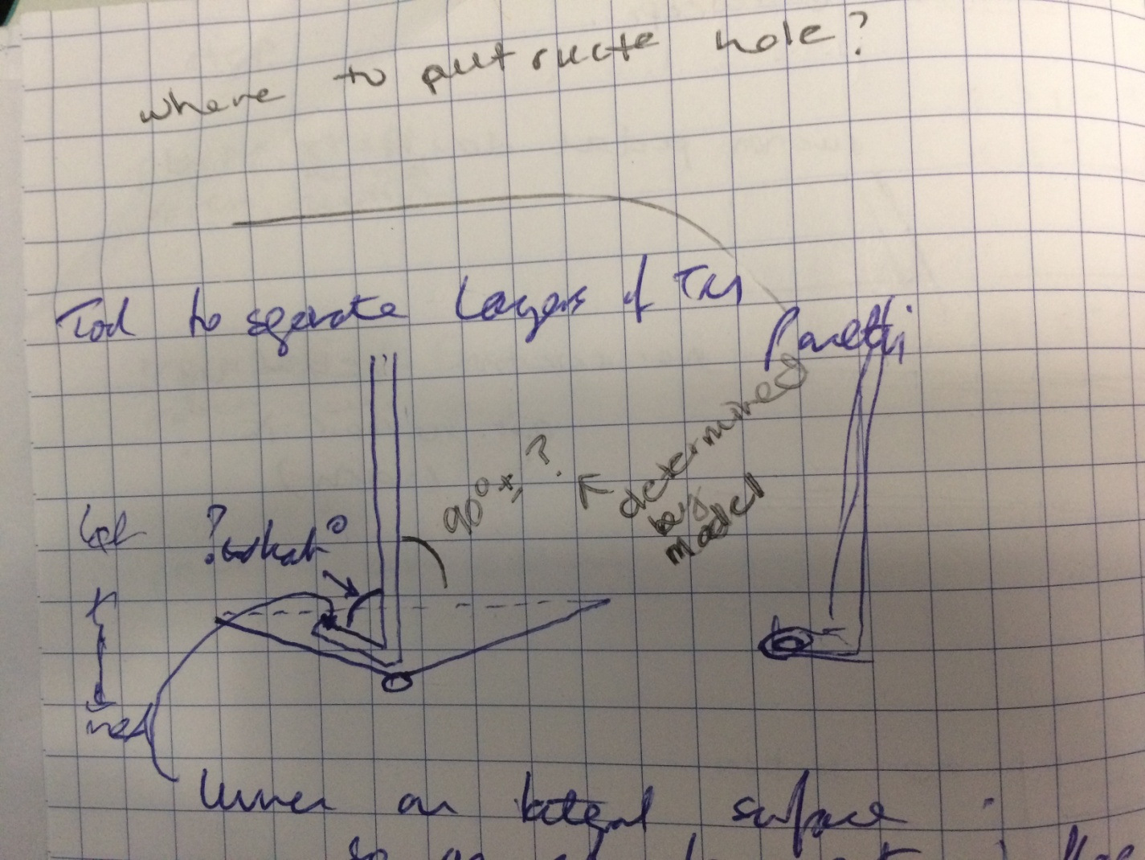

Problem: left and right Panetti suckers are not perfect – the bend angle is 90deg.

* 90deg not optimal for ear drum which is not perfectly flat
* What is the optimal bending angle for the Panetti sucker?

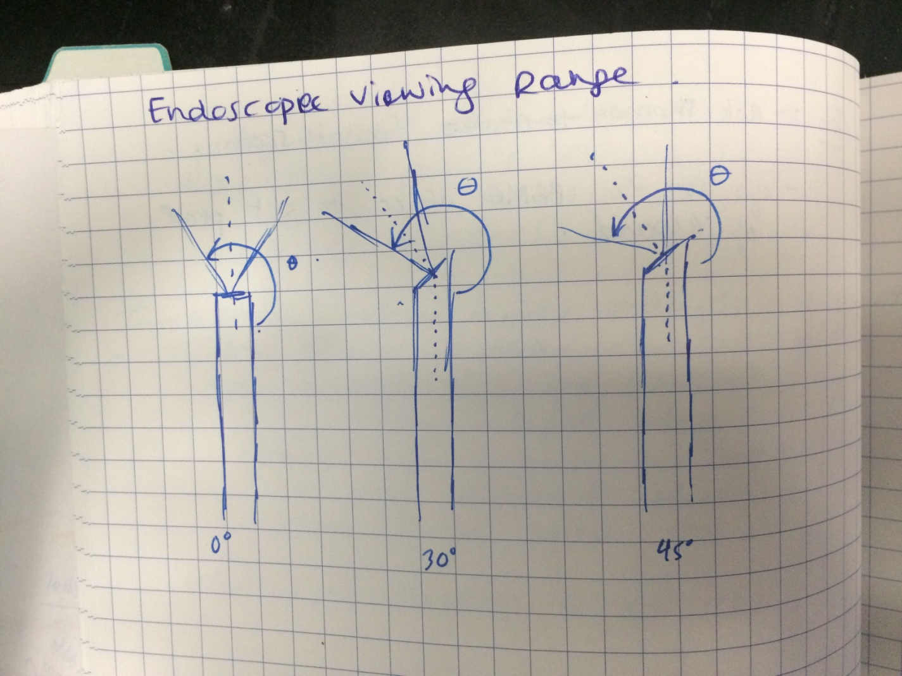

Problem: cannot reach the areas visualized by the endoscope. Need a tool that can bend around the endoscope to reach something.

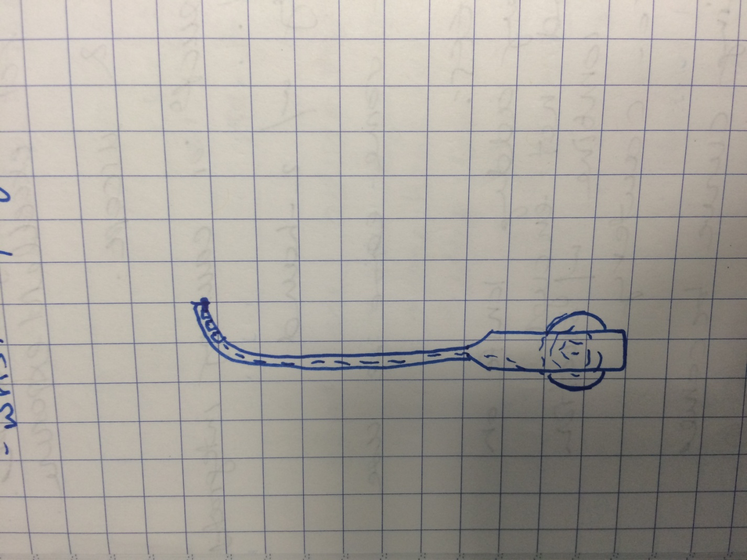

Can use a wrist or concentric tubes to reach into the viewing field of the endoscope. Problem: need to feed instrument in straight, alongside endoscope and then bend (could be done by an instrument with a permanent bend in the middle or a bendable tip e.g. concentric tubes or wrist)

Handle is actuated via dial for the thumb

Question: what is the tip doing? 🡪 Workspace analysis

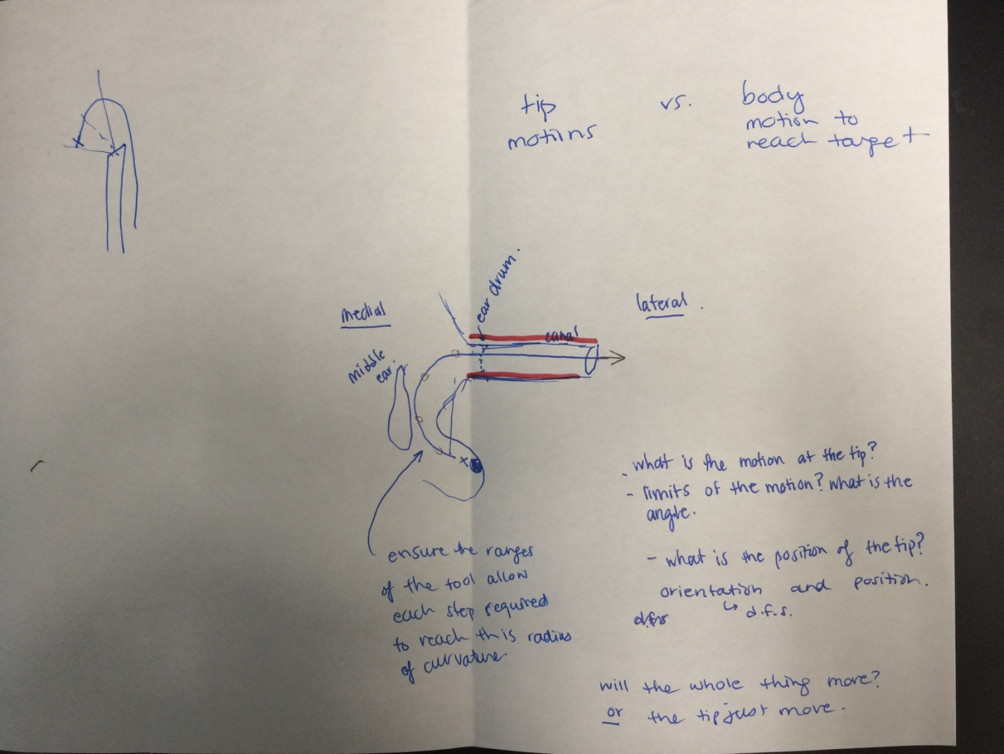

Workspace Analysis:

1. Tip Design

* Measure the orientation space using electromagnetic electrodes at the tip of a printed Rosen
* Measures the orientation of the tip while dissecting
* 3D print ear model for this

1. Body Design

* 3D printed ear model with orientation space and endoscope added to it
* Add a stick and play around with the geometries to figure out appropriate body angles/bends/curves to access certain regions – antrum and sinus tympani

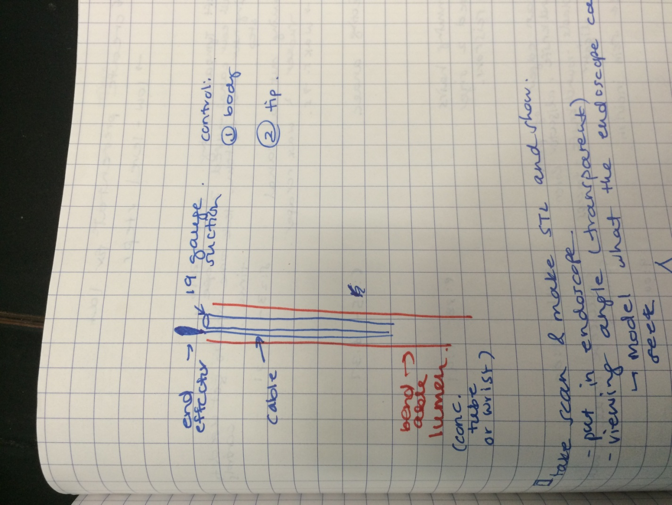

End effecter actuated via wires (e.g. forceps or curette) and suction down the lumen – like the Grace medical instruments but cut the tip of the lumen so the end effecter and suction are more closely integrated -> complicated handle design is not ideal for surgeons as they will have to learn how to use it -> make it easy and intuitive/native to the way that their current instruments work

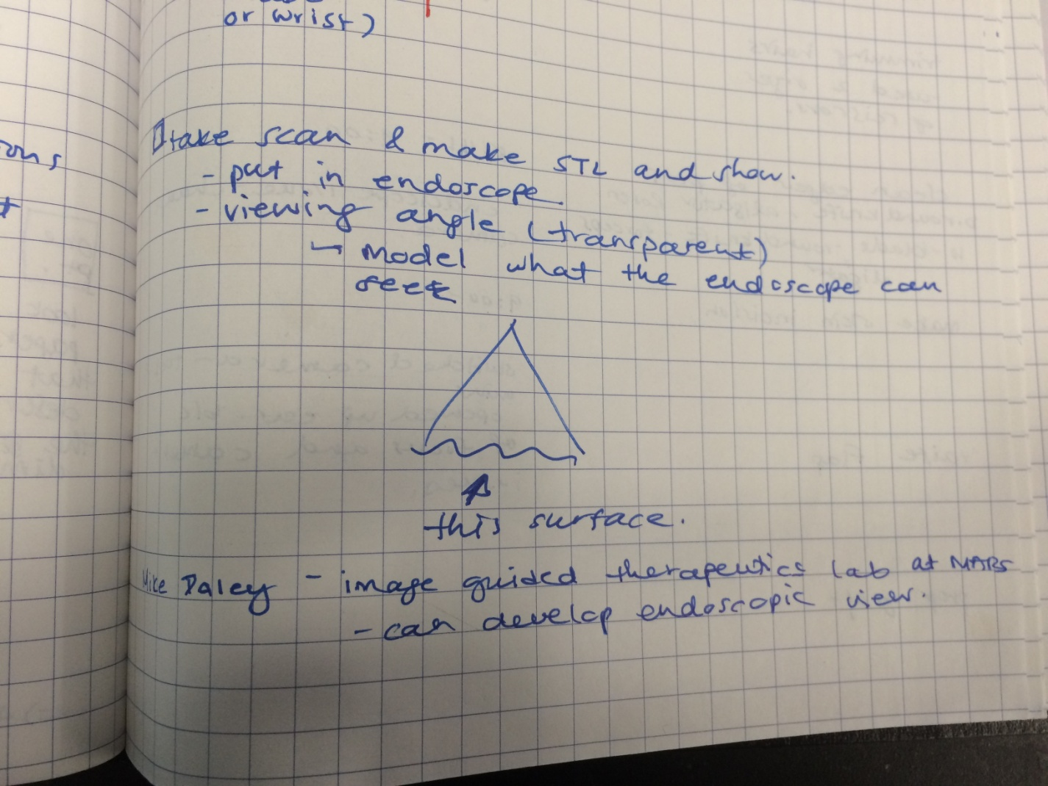

Make a surface STL that shows the direct view of the endoscope

Spoke with Harley (Mike Daley’s colleague) about this and he can make it as long as we provide a CT image with at least 0.5mm resolution, isotropic

If we publish using his contribution, we add him as co-author (that is his payment)

Oct-2016

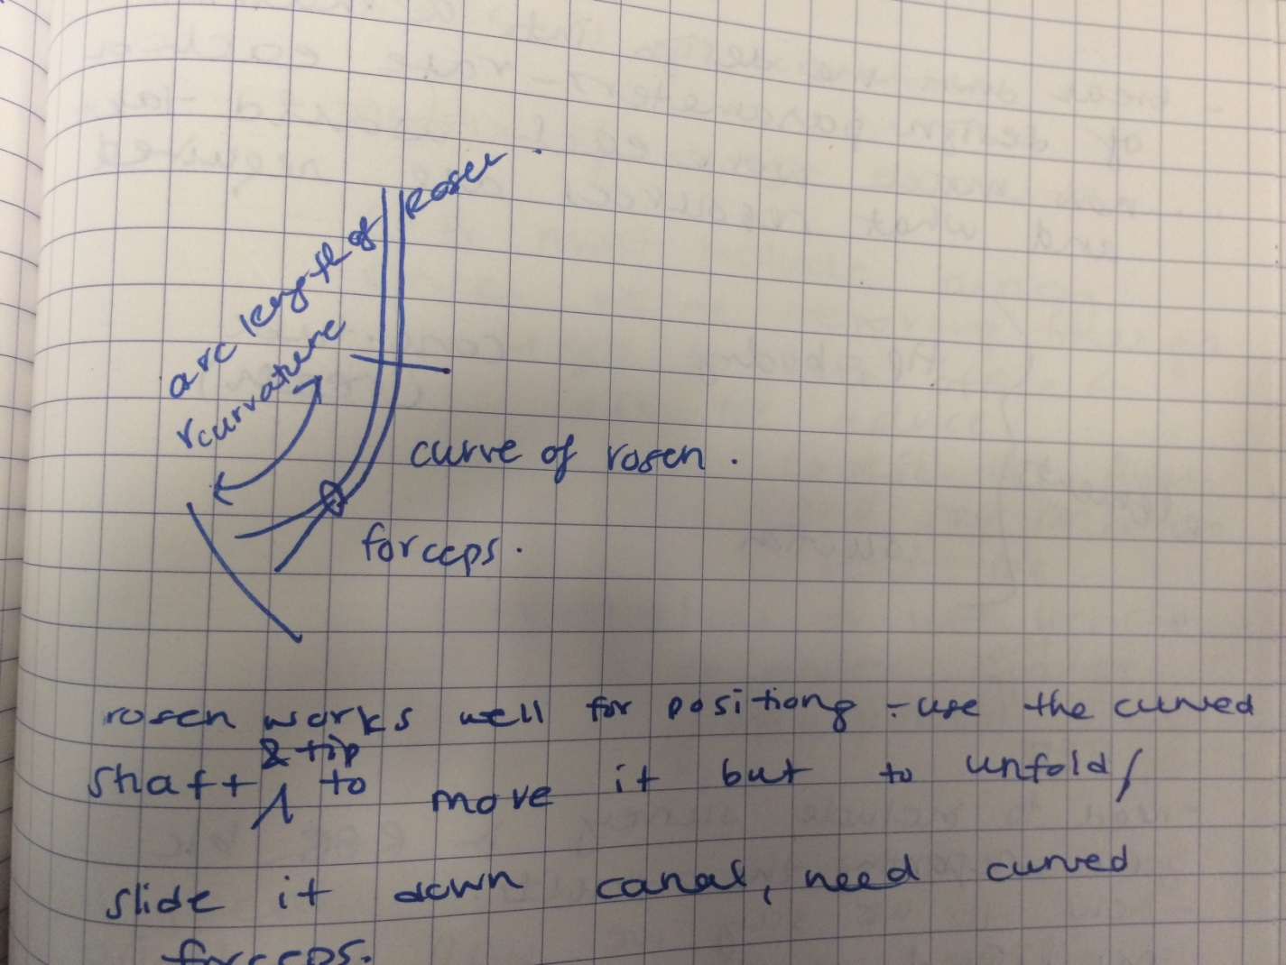

Curve forceps into Rosen needle bend to help facilitate graft movement

Graft introduction uses the forceps to place it into the ear canal first and then the rosen needle is used to slide it down the canal and position it

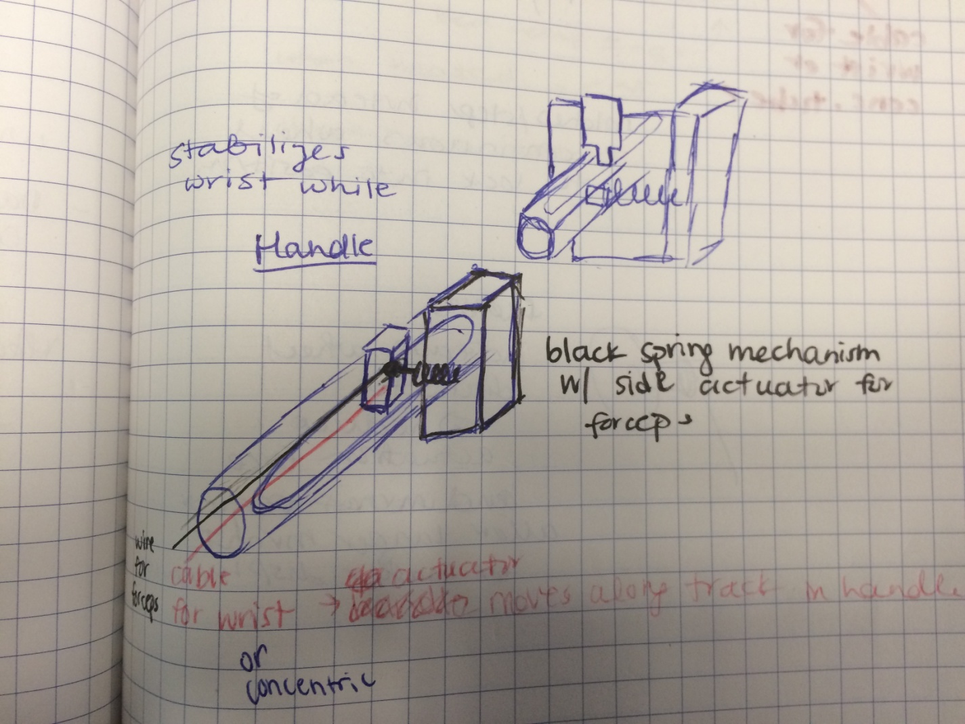

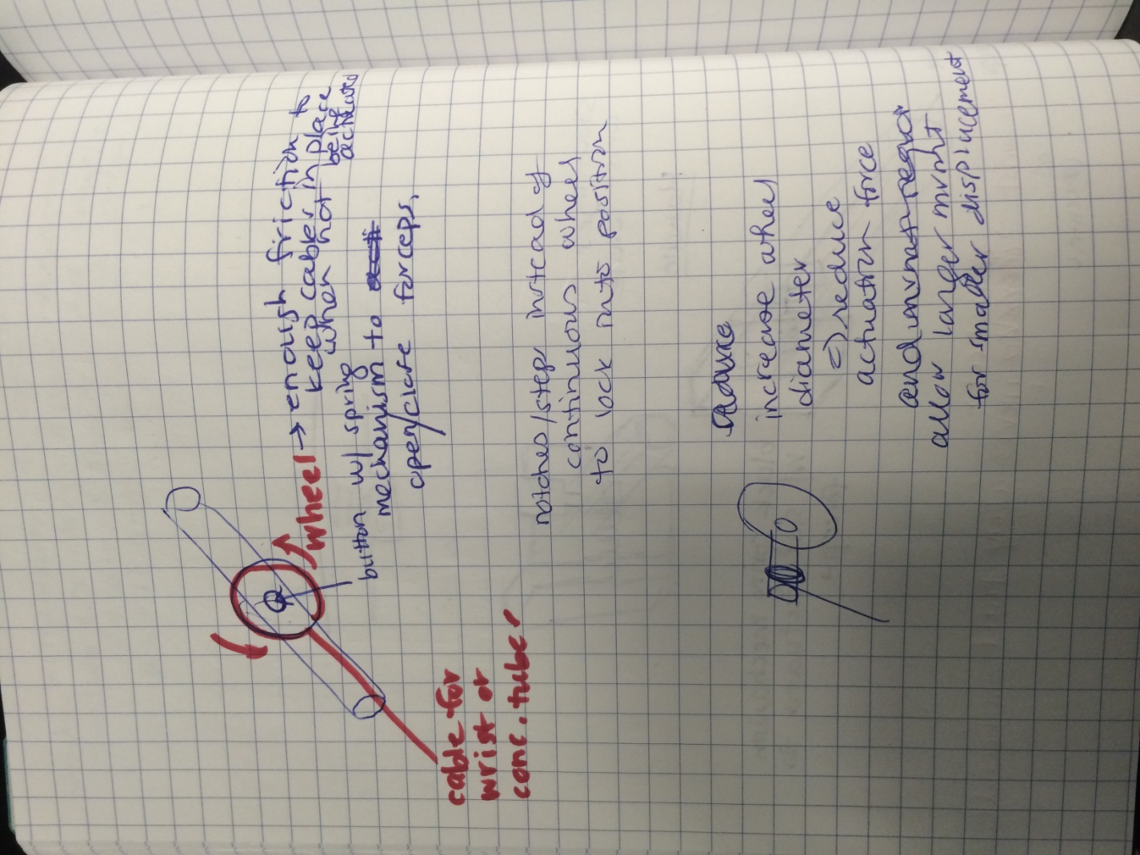

* Slider or dial mechanism to actuate concentric tubes and forceps
* Decoupled forceps and concentric tubes: use dial + button in the middle (probably only allows either open or closed, not in the middle)
  + Dial + slider underneath
* Coupled forceps and concentric tubes: use slider with button to actuate forceps (more control, able to half open forceps)
* Need to lock the dial in place – notches in the dial that locks the tubes in place
* Also want stiff tubes (as per feedback from EES course 19-Oct-2016) therefore lock would help that, and selecting the material, thickness
* Dial -> can calibrate the force vs. displacement -> wrap cable around thin axle attached to large dial -> large dial displacement = small cable displacement
* Use friction pads to ensure the dial doesn’t move to easily
* After the course – it seems that for greater adoption of tools, a very simple tool (without moving parts) would be more widely accepted
* The concentric tubes introduces the risk of how to retract the instrument quickly without having to think too much about how it got there – therefore, workspace study will be useful to figure out the appropriate geometry to permanently bend a sucker and its tip to access the necessary regions.

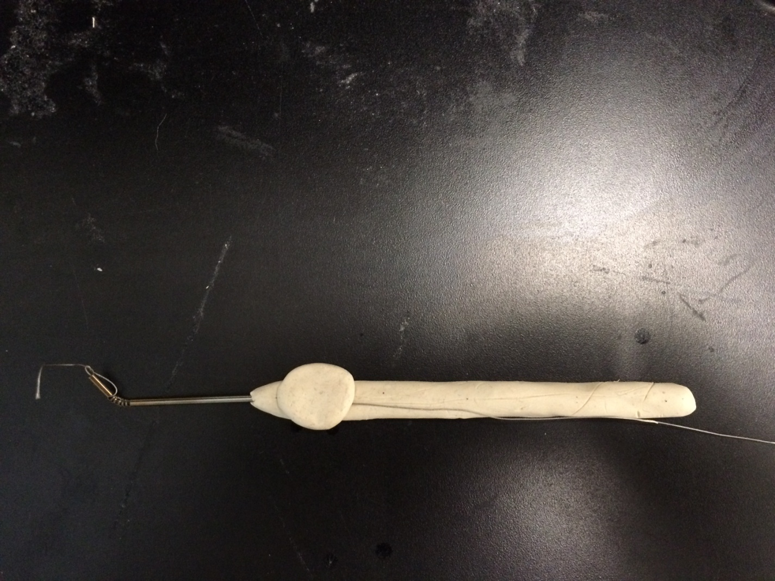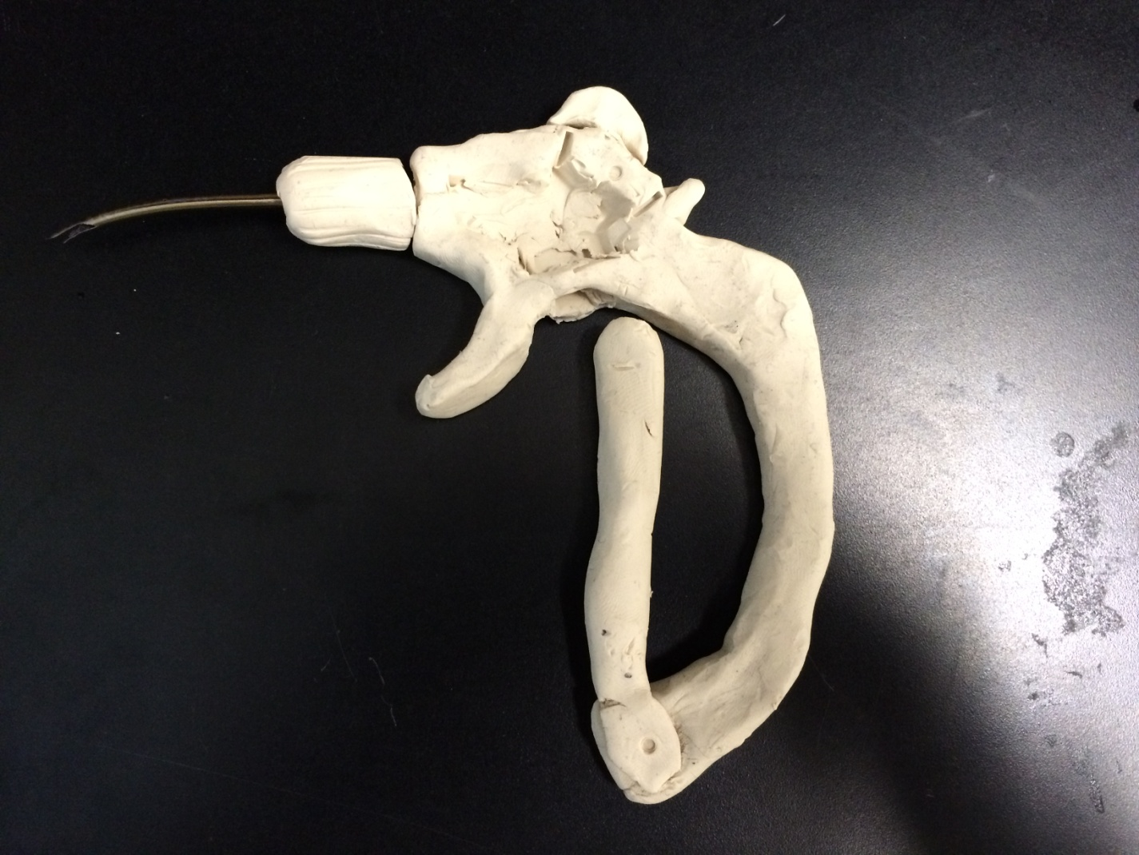

* Internal regulatory required for instrument use and publication needs REB
* Easier to get regulatory if the instrument is similar to existing (shape, function and material)
* If using the flexible wrist or concentric tubes, will be more complicated process to get approval to use in the patient